DA-LP1101R/T

Architectural and Engineering Specifications
Version 1.1
(Jun. 15, 2021)

PART 2 - PRODCUTS
Division 27 – Communications
Section 27.16.16 – Communications Media Converters, Adapters, and Transceivers

Manufacturer
- IDIS Co., Ltd.
IDIS Tower, 344 Pangyo-ro, Bundang-gu
Seongnam-si, Gyeonggi-do, 13494, Republic of Korea
Tel: +82 31 723 5028
Fax: +82 31 723 5100

General

Product Description
DA-LP1101R/T is a long distance networking-specific solution that supports Ethernet connections up to 500 meters. This versatile connector empowers integrators and end users to establish networks beyond the limitations of common cables requiring repeater connections every 100 meters. By connecting a network video recorder (NVR) and camera with the IDIS Long Reach PoE Extender, users can now build a network without multiple separate repeater connections, enabling cost savings and simplifying network environments.

General Specification
- The device shall be equipped with 1 RJ-45 PD (Powered Device) and 1 RJ-45 PSE (Power Sourcing Equipment).
- The device shall be equipped with RJ-45, auto-MDI/MDI-X sensing connectivity.
- The device shall support up to 30W PoE.(Depending on cable distance and power input)
- The device shall support up to 30W PoE power budget.
- The device shall be equipped with 10/100/1000 Base-T(DA-LP1101R), RJ-45 Ethernet connection.
- The device shall support up to 500m PoE transmission between devices using UTP cabling.
- The device shall support up to 700m data transmission between equipment using UTP cabling.
- The device shall support plug-and-play without any required PC settings.
- The device shall support 1Gbps / IEEE802.3at for PoE Injector. (DA-LP1101R)
- The device shall support 1Gbps / IEEE802.3at / 100 meters for PoE Repeater. (DA-LP1101R)

Technical Specification

Specification of DA-LP1101R operated as PoE Injector or PoE Repeater
- Port
  - RJ-45 x 1 with PD
  - RJ-45 x 1 with PSE
- Connectivity: RJ-45, Auto-MDI/MDI-X Sensing
- Power Input: IEEE 802.3at, 48 ~ 56V DC
- Power Output: Max. 720mA
- PoE Standard
  - IEEE 802.3at PD
  - IEEE 802.3at PSE
- PSE Budget: Up to 30W
- Speed: 10/100/1000Mbps

Specification of DA-LP1101R/T operated as Long Reach PoE Extender
- Port
  - RJ-45 x 1 with PD
  - RJ-45 x 1 with PSE
- Connectivity: RJ-45, Auto-MDI/MDI-X Sensing
- Power Input: IEEE 802.3at, 48 ~ 56 V DC
- Power Output: Max. 720mA
- Power Consumption : 56V, 0.786A, 44W
- PoE Standard
  - IEEE 802.3at PD
  - IEEE 802.3at PSE
- PoE Budget: Up to 30W (Depending on Cable Distance and Power Input)
- Wire type: UTP CAT5E or Above
- Speed: 10/100Mbps

LEDs and Button
1. Link status LED: 2 Yellow LED (Link / Activity LED per Ethernet Port)
2. PoE Status: 1 Green LED (PSE LED)
3. Reset Button: None
4. Power LED: 1 Green LED

Mechanical Specifications
- Unit Dimensions (W x H x D): 104 mm x 34 mm x 96 mm (4.09" x 1.34" x 3.78")
- Unit Weight: 226g ( 0.49lb)

Environmental Specifications
- Working Temperature: -10°C to 50°C (14℉ ~ 122℉)
- Operating Humidity: 0% ~ 90%

Electrical Specifications
- Regulatory Approvals:
  - Electrical: KC, CE, FCC
- PoE Output Capability
Distance | Data Rate | DA-LP1101T IEE802.3at PoE Output Capability (Using UTP CAT5E Cable)
 |  | DA-LP1101R  with IEEE 802.3at | DA-LP1101R  with 56V DC Input | DA-LP1101T  with 56V DC Input
100m | 100Mbps | 19.65W | 27.80W | 30.68W
200m | 100Mbps | 18.28W | 25.57W | 30.68W
300m | 100Mbps | 16.81W | 23.24W | 30.68W
400m | 100Mbps | 16.00W | 20.85W | 30.68W
500m | 100Mbps | 13.36W | 18.01W | 30.68W
600m | 100Mbps |  |  | 30.68W
700m | 100Mbps |  |  | 30.68W

Appendix. A IDIS Long Reach PoE Installation
      - Installation with PoE NVR or Switch
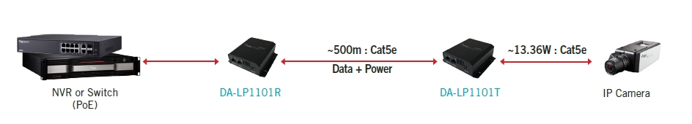
      - Installation with External DC Power (DA-LP1101R)
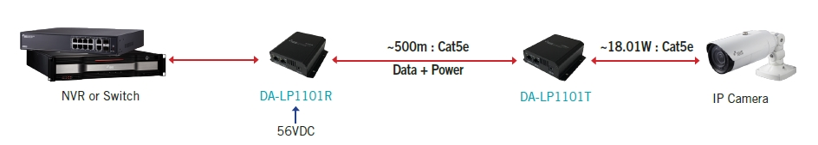
      - Installation with External DC Power (DA-LP1101T)
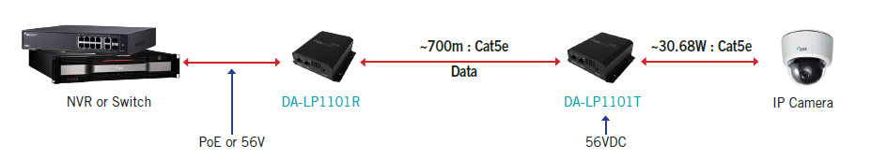
      - Installation for PoE Repeater
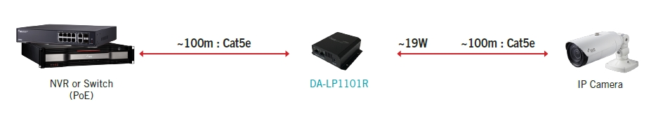
      - Installation for PoE Injector
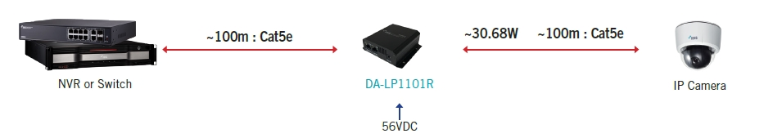

Version History
Version | Writer | Revision Date | Remarks
1.2 | IDIS TS | Nov. 29, 2022 | Added Power Consumption
1.1 | Daniel Lee | Jun. 15, 2021 | Dimension was changed.
1.0 | Brandon Jo | Mar. 30, 2017 | Initial Release

